**Christopher King**

**2018141521058**

**Mechanical Design 1**

**Class Section 01**

**10/31/2020**

# **Problem 1**

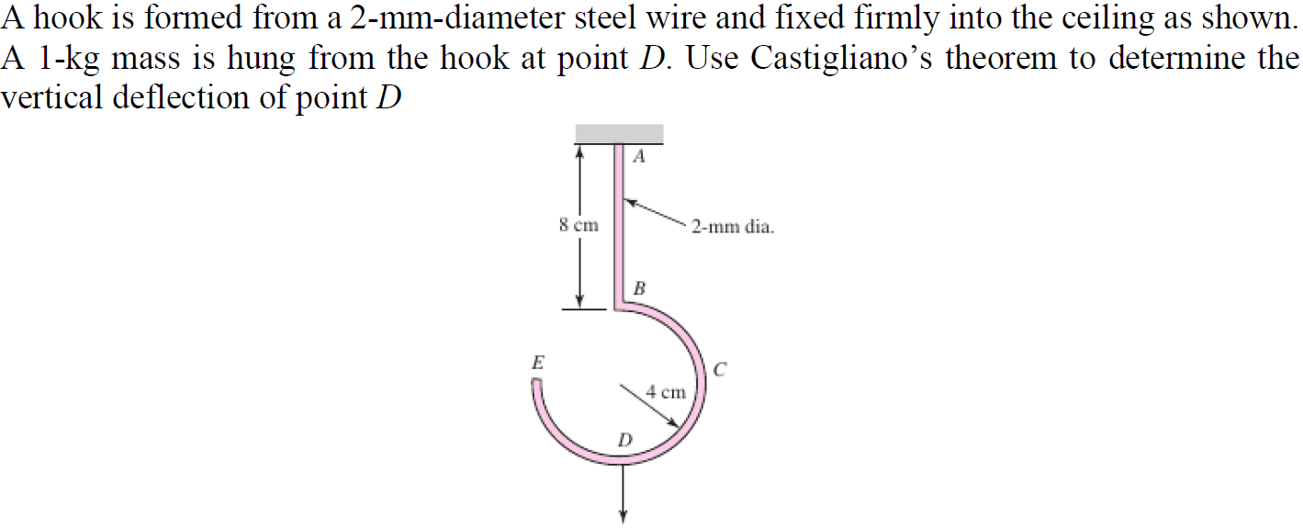

**Solution:**

For this question, we are asked to determine the vertical deflection of point .

# **Problem 2**

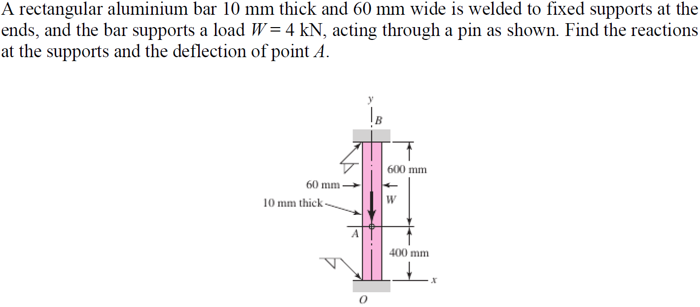

**Solution:**

For this question, we are asked to find the reactions at the supports and the deflection of point .